**Module – 1 (Fundamental)**

Q.1 What is SDLC

* Full form of SDLC is Software Development Life Cycle
* SDLC has different steps or phases like requirement gathering, analysis, design, implementation, testing and maintenance.

Q.2 What is software testing?

* Software Testing is a process used to identify the correctness, completeness and quality of developed computer software.
* It is also known as a process for verifying and validating a software or application.

Q.3 What is agile methodology?

* Agile methodology is one of the most useful and important software testing methodologies.
* Agile model is combination of iterative and incremental models.
* Agile model is used for long term projects which has no deadline.

Q.4 What is SRS

* Full form of SRS is Software Requirement Specification.
* SRS is used to describe the requirements for the software development.
* Use case diagrams are used for showing requirements.

Q.5 What is OOPS

* Full form of OOPS is Object Oriented Programming System.
* Object oriented programming is a methodology to design a program using classes and objects.

Q.6 Write basic concepts of OOPS.

* Object
* Class
* Encapsulation
* Inheritance
* Polymorphism
* Abstraction

Q.7 What is object

* Object means a real world entity such as pen, chair, table etc.
* Object is basic unit of OOPS.

Q.8 What is class

* Collection of objects is called class.

Q.9 What is encapsulation

* Encapsulation means data hiding, hiding irrelevant information from the users.

Q.10 What is inheritance

* Inheritance means that one class inherits the characteristics of another class.
* This is very important concept of object-oriented programming.

Q.11 What is polymorphism

* Polymorphism means it allows different objects to respond to the same message in different ways.
* Ability to change form is known as polymorphism.
* There are two types of polymorphism

1. Overloading
2. Overriding

Q.12 Write SDLC phases with basic information

* Requirements gathering
* To establish customer needs
* There are two types of requirements

1. Functional
2. Non-functional

* Analysis phase
* Analysis phase defines the requirements.
* This phase defines the requirements from the customer’s perspective by defining goals
* Design
* This phase defines the component, their interface and behavior.
* Requirements are now in the design form.
* Implementation Phase
* In this phase, team builds the components from scratch or by composition.
* In this phase component is build according to requirements and design.
* This phase deals with issues of quality, critical error removal, performance etc.
* Testing Phase
* Testing phase includes the testing of quality, design, functions etc., hence it is very important phase.
* Different types of tests are performed in this phase like regression testing, internal testing, Unit testing, application testing etc.
* After the implementation is completed, testing is performed by different teams.
* Maintenance phase
* This phase includes the process of enhancing and optimizing deployed software, as well as fixing defects.
* There are 3 types of maintenance

1. Corrective
2. Adaptive
3. Perfective

Q.13 Explain phases of the waterfall model

* There are six phases of waterfall model:
* Requirements gathering
* To establish customer needs
* There are two types of requirements

1. Functional
2. Non-functional

* Analysis phase
* Analysis phase defines the requirements.
* This phase defines the requirements from the customer’s perspective by defining goals
* Design
* This phase defines the component, their interface and behavior.
* Requirements are now in the design form.
* Implementation Phase
* In this phase, team builds the components from scratch or by composition.
* In this phase component is build according to requirements and design.
* This phase deals with issues of quality, critical error removal, performance etc.
* Testing Phase
* Testing phase includes the testing of quality, design, functions etc., hence it is very important phase.
* Different types of tests are performed in this phase like regression testing, internal testing, Unit testing, application testing etc.
* After the implementation is completed, testing is performed by different teams.
* Maintenance phase
* This phase includes the process of enhancing and optimizing deployed software, as well as fixing defects.
* There are 3 types of maintenance

1. Corrective
2. Adaptive
3. Perfective

Q.14 Write phases of spiral model

* There are 4 phases in Bohem’s Spiral model

1. Planning
2. Risk Analysis
3. Engineering
4. Customer evaluation

Q.15 Explain working methodology of agile model and also write pros and cons.

* Agile model is a combination of iterative and incremental models.
* Agile model break the product into small incremental builds.
* These builds are provided in iterations.
* Every iteration involves cross functional teams working simultaneously on various areas like planning, requirements analysis, design, coding, unit testing, and acceptance testing.
* Pros:

- Agile model is used for long term projects which has no deadline.

- Easy to manage.

- Suitable when requirements are not fixed.

- Gives flexibility to developers

* Cons:
* Not suitable for handling complex dependencies.
* Transfer of technology to new team members may be quite challenging due to lack of documentation.
* Depends heavily on customer interaction, so if customer is not clear, team can be driven in the wrong direction.

Q.16 Draw usecase on online book shopping

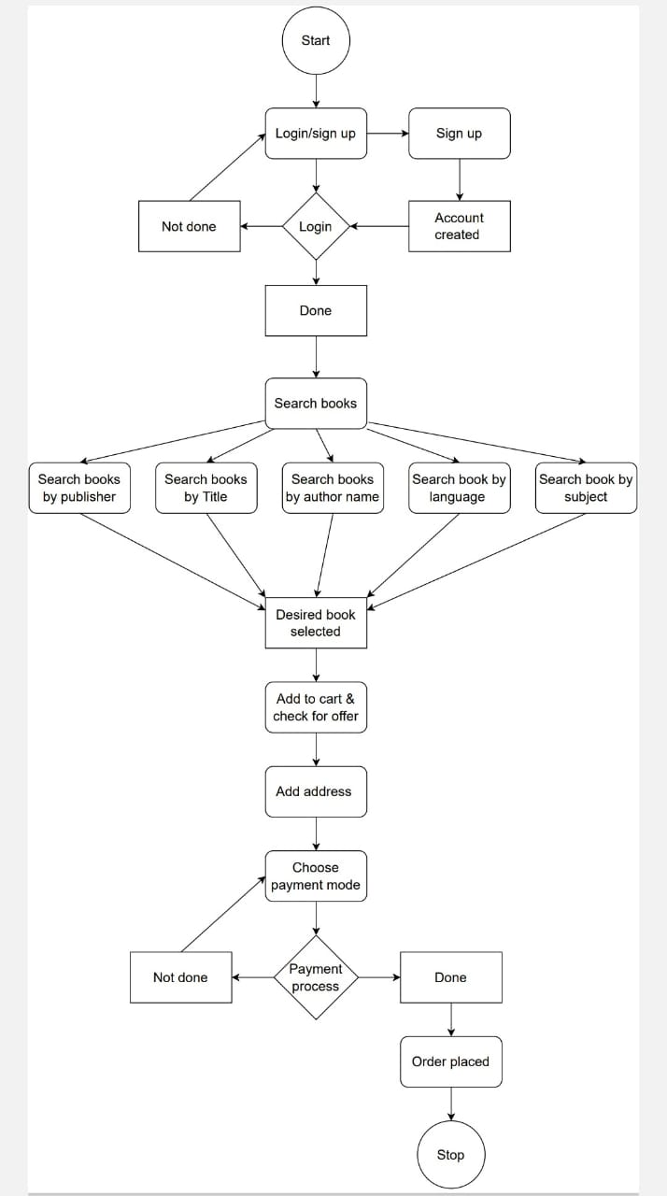

Q.17 Draw usecase on online bill payment system (paytm)

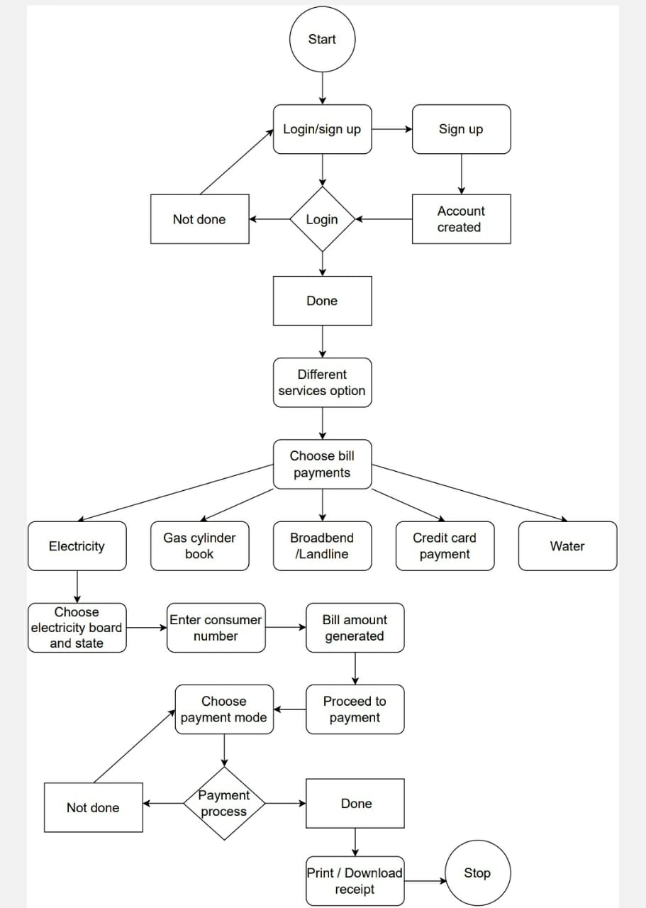

Q.18 Draw usecase on Online shopping product using COD.

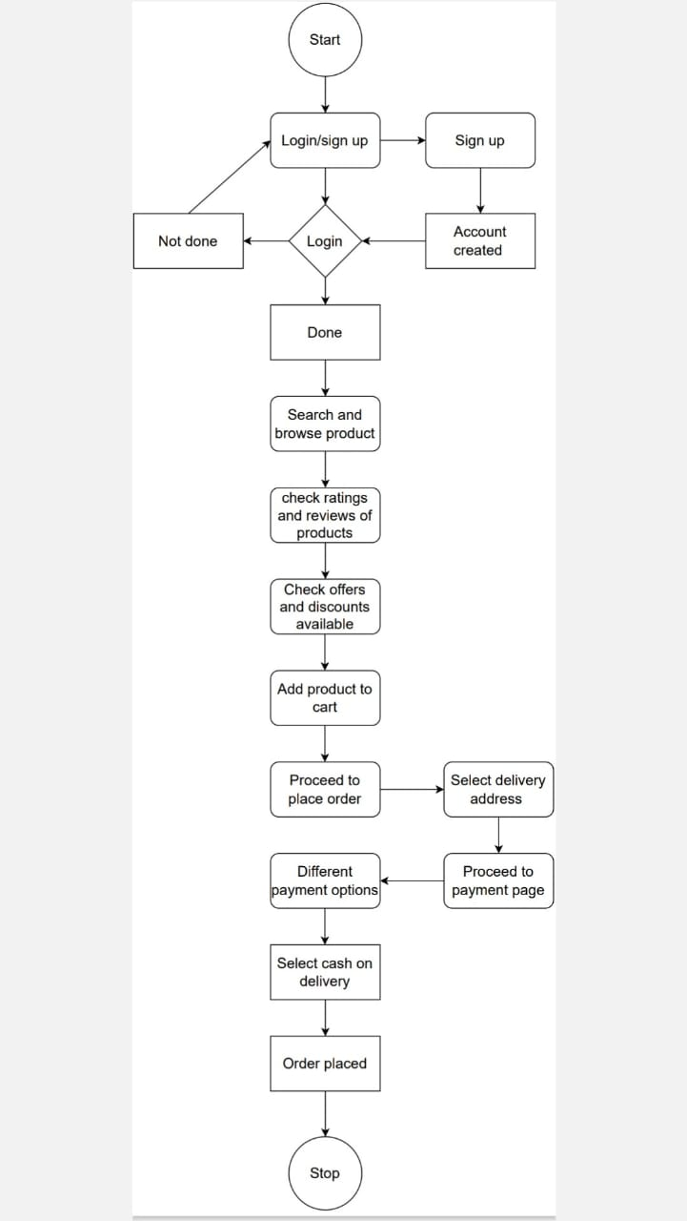

Q.19 Draw usecase on Online shopping product using payment gateway.

